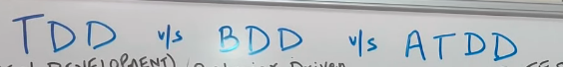

Tdd is also known as implementation centric approach.

Test first approach- first test it, then refactor code to see if tests are passing or not and keep doing this for n-cycles till all test cases developed are passed.

High level requirement means simple documentation like the requirement is written by PO or business stakeholders in a word document or spreadsheet etc at a higher level.

# Note-

Selenium is a library to automation ui applications. Selenium is not related to bdd.

Bdd can be used for api, mobile, web apps.